**PJ 5 Report Your Name: Francisco Valadez**

**A. The following is my Java program:**

**// Please copy your Java program into here from your Eclipse window. The code must be colored.**

**// You must not copy Java program from your .java file since the code over there is not colored at all.**

**// You must not show screen prints here.**

//Author:       Francisco Valadez

//Date:         5/26/2021

//Purpose:      This program converts from infix to postfix!

import java.util.Scanner;

import java.util.Stack;

public class Postfix

{

    //converts User input to post fix

    public static String Convert(String userInput)

    {

        String post = "";

        int counter = 0; //keeps track of spaces

        Stack<Character> items = new Stack<Character>();

        for(int i = 0; i < userInput.length(); i++)

        {

            if((userInput.charAt(i) == '+') || (userInput.charAt(i) == '-') || (userInput.charAt(i) == '*') || (userInput.charAt(i) == '/'))

            {

                while((items.peek() != '(') && (items.isEmpty() == false))

                {

                    post += items.peek();

                    post += " ";

                    items.pop();

                }

                items.add(userInput.charAt(i));

                counter = 0;

            }

            else if((userInput.charAt(i) >= '0') && (userInput.charAt(i) <= '9'))

            {

                post += userInput.charAt(i);

                counter = 0;

            }

            else if (userInput.charAt(i) == '(')

            {

                items.add(userInput.charAt(i));

            }

            else if (userInput.charAt(i) == ')')

            {

                while(( items.isEmpty() == false) && ( items.peek() != '('))

                {

                    post += items.peek();

                    post += " ";

                    items.pop();

                }

                items.pop();

            }

            else if(userInput.charAt(i) == ' ')

            {

                if(counter < 1)

                {

                    post += " ";

                }

                counter++;

            }

        }

        while(items.isEmpty() == false)

        {

            post += items.peek();

            items.pop();

        }

        return post;

    }

    //Calculates the total

    public static double Total(String userInput)

    {

        String post = Convert(userInput);

        int var1, var2, postTotal = 0;

        Stack<Character> items = new Stack<Character>();

        for(int i = 0; i < userInput.length(); i++)

        {

            if((userInput.charAt(i) == '+') || (userInput.charAt(i) == '-') || (userInput.charAt(i) == '*') || (userInput.charAt(i) == '/'))

            {

                var1 = (int)items.pop();

                var2 = (int)items.pop();

                if (postTotal == 0)

                {

                    switch (userInput.charAt(i))

                    {

                        case '+':

                            postTotal = var1 + var2; break;

                        case '-':

                            postTotal = var1 - var2; break;

                        case '*':

                            postTotal = var1 * var2; break;

                        case '/':

                            postTotal = var1 / var2; break;

                    }

                }

                else

                {

                    switch (userInput.charAt(i))

                    {

                        case '+':

                            postTotal = postTotal + var2; break;

                        case '-':

                            postTotal = postTotal - var2; break;

                        case '*':

                            postTotal = postTotal * var2; break;

                        case '/':

                            postTotal = postTotal / var2; break;

                    }

                }

            }

            else if ((userInput.charAt(i) >= '0') && (userInput.charAt(i) <= '9'))

            {

                items.add(userInput.charAt(i));

            }

        }

        return 0;

    }

    public static void main(String[] args)

    {

        int counter = 1;

        double total = 0;

        Scanner input = new Scanner(System.in);

        String userInput = "";

        System.out.println("Welcome to the Postfix Expression Tool of Francisco Valadez!");

        System.out.println(counter + "===============================================");

        System.out.println("Please enter a fully-parenthesized infix expression: ");

        userInput = input.nextLine();

        while (userInput.equals("0") != true)

        {

            counter++;

            System.out.println("Postfix expression: " + Convert(userInput) );

            //total = Total(userInput);

            System.out.println("Final result: " + total);

            System.out.println(counter + "===============================================");

            System.out.println("Please enter a fully-parenthesized infix expression: ");

            userInput = input.nextLine();

        }

        System.out.println(counter + 1 + "===============================================");

        System.out.println("Thank you for using this Postfix Evalutaion Tool of Francisco Valadez!");

        System.out.println(counter + 2 + "===============================================");

    }

}

**B. The following is the complete output of my 3 test cases: [You must show 3 test cases.]**

**// Please copy your Eclipse console output into here.**

**Test Case 1:**

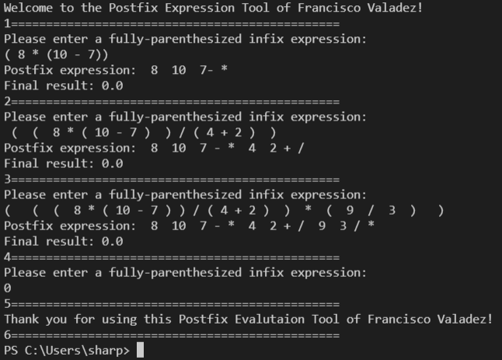

**Test Case 2:**

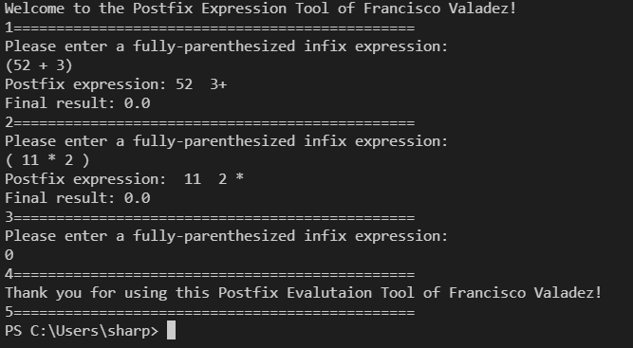

**Test Case 3:**

